Second Assessment

By: David Clarke
Course: Electrical & Electronic Engineering2
Date:2/5/2000

1).

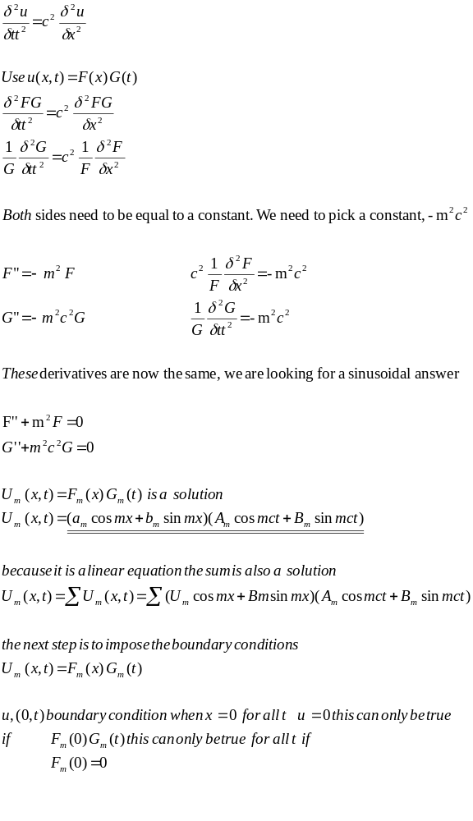

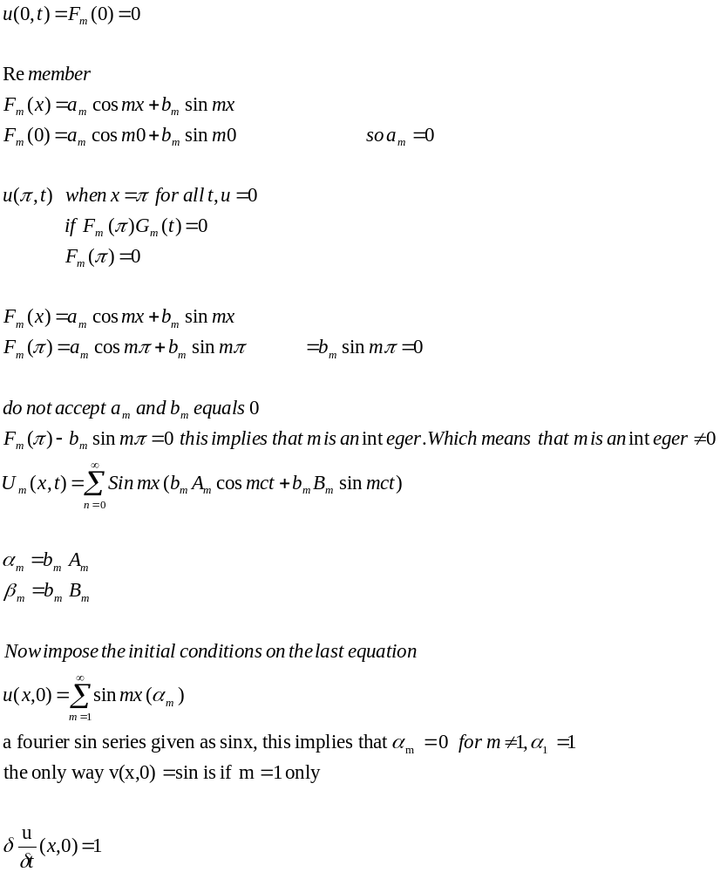

for all 0<x<π
rhs = 0 at x=0, x = π

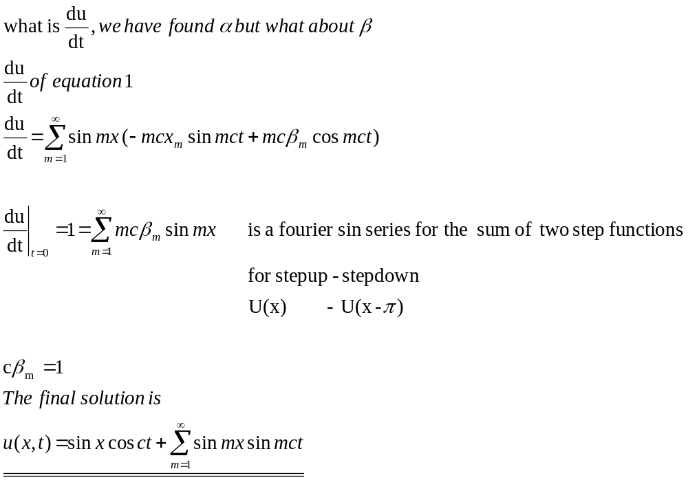

2).
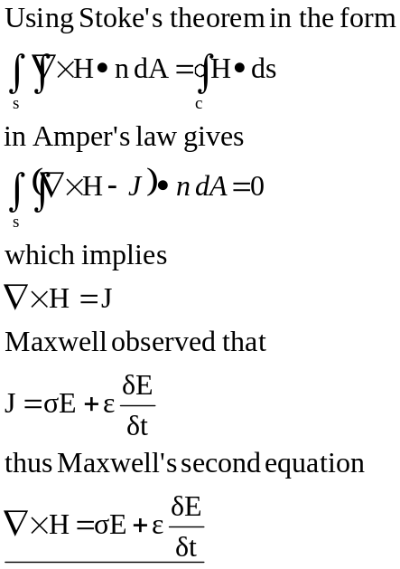

3).

A
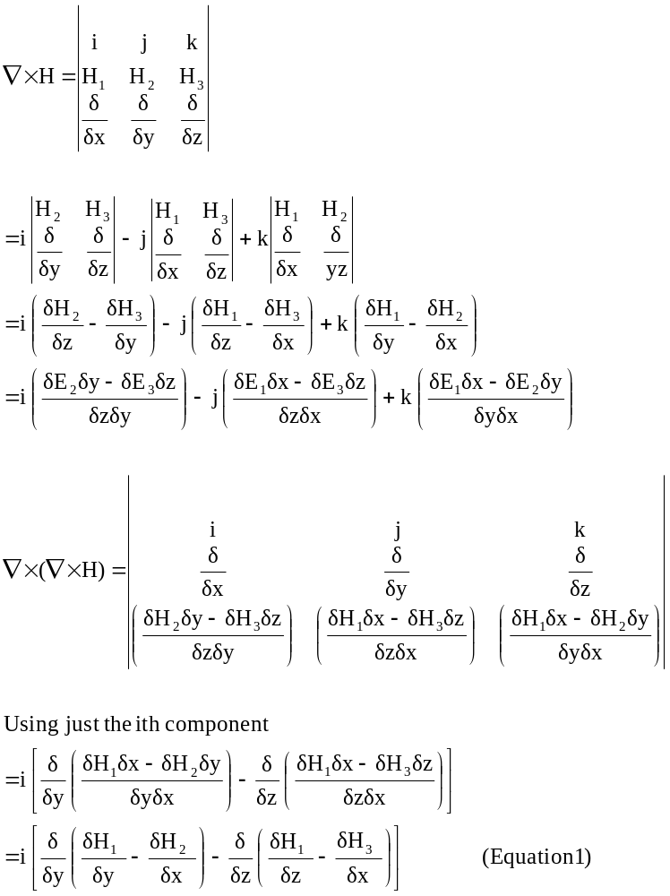

B
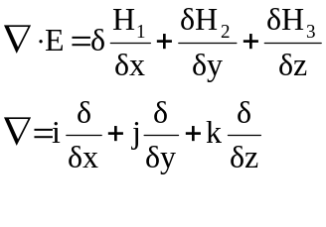

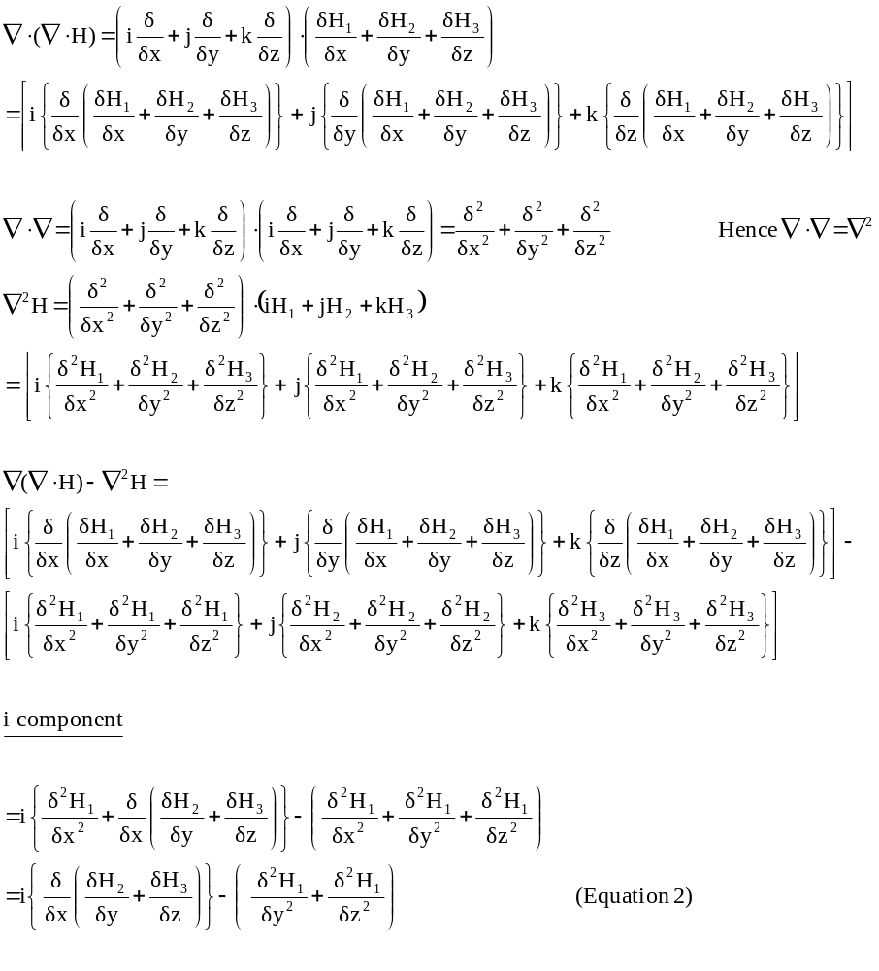Comparing equations 1 and 2, it can be seen that their i components are equal.

4).

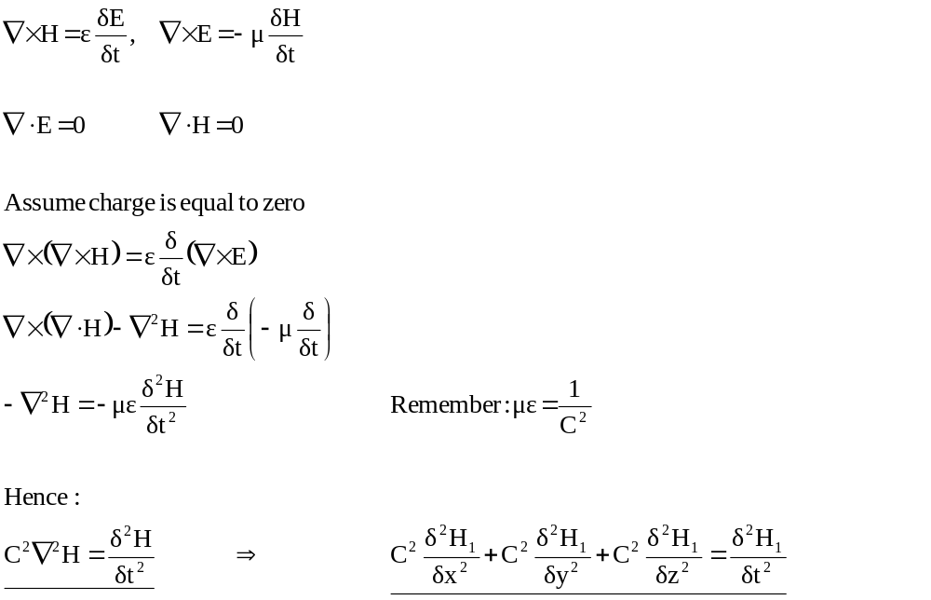

5.)

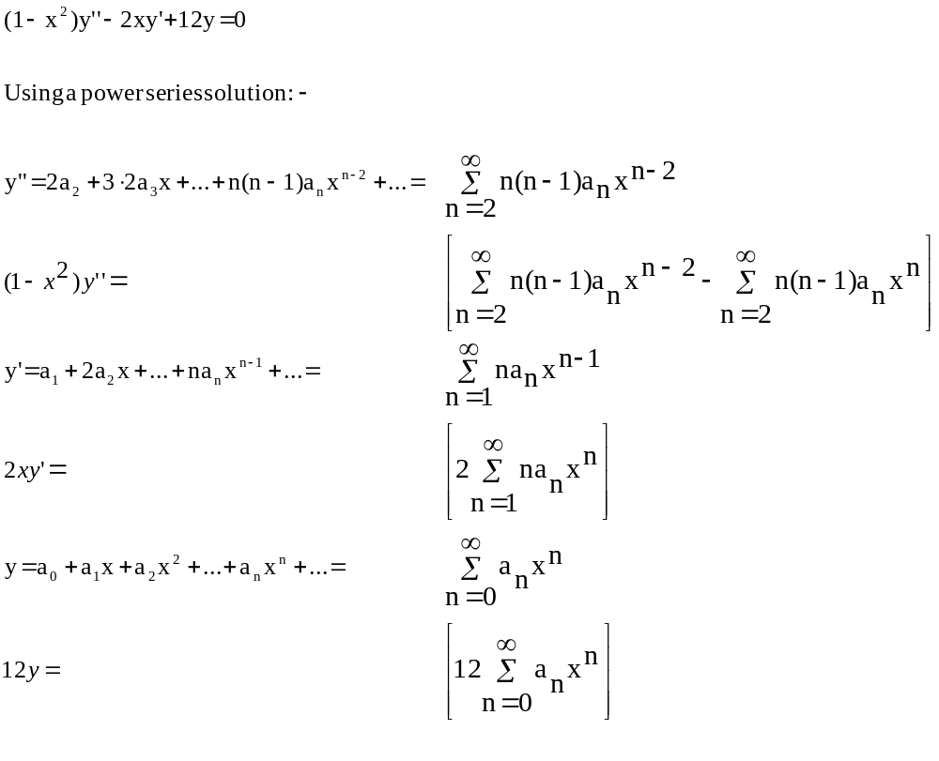Hence:-

By shifting the summations by letting n = m + 2 in the y’’, for the other terms, replace n with m :-

(m + 2)(m + 1)a_{m+2}x^{m} – m(m – 1)a_{m}x^{m} – 2ma_{m}x^{m} + 12a_{m}x^{m} = 0

Divide through by x^{m}:-

(m + 2)(m + 1)a_{m+2} – m(m – 1)a_{m} – 2ma_{m} + 12a_{m} = 0

Re-arrange in terms of a_{m+2}:-

m(m – 1)a_{m} + 2ma_{m} - 12a_{m} = (m + 2)(m + 1)a_{m+2}

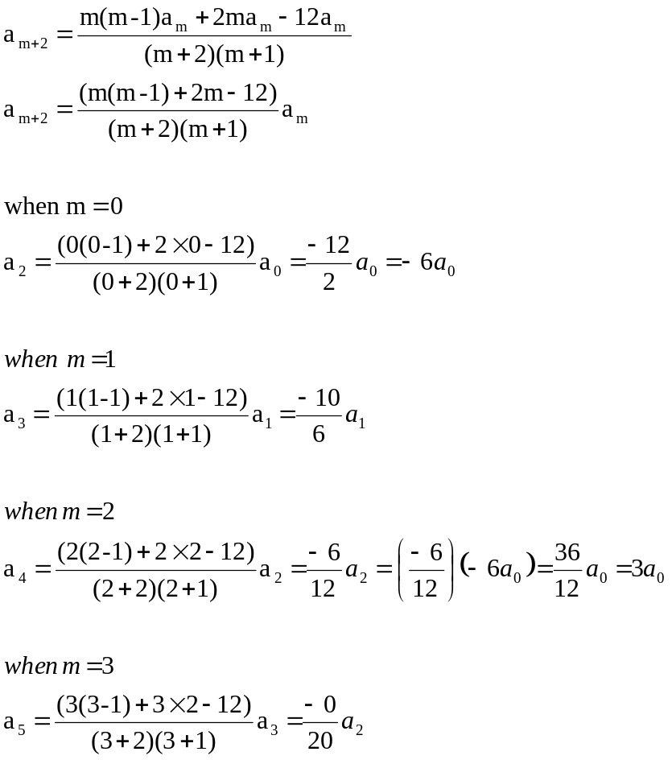

When m is even all terms are related to the arbitrary constant a₀. When m is odd all terms are related to the arbitrary constant a₁.

Hence:-

Y(x) = a₀ + a₁x - 6 a₀x² + (-10/6)a₁x³ + 3a₀x⁴

Y(x) = a₀ (1 – 6x² + 3x⁴+…..) + a₁(x – 10/6x³)

Does the series terminate or converge for x <1?

The a₀ coefficients converge to a value of 2. The a₁ coefficients terminate past the second term in it’s series.

6).

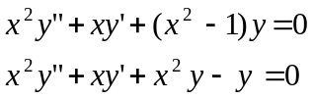

Using the Frobenius method to attempt a solution of a Frobenius series, we have:-

